PROBABILITY AND STATISTICS

(UCS410)

ASSIGNMENT 6

SUBMITTED BY TARUSHI GERA

102103391, 2COE29

1.

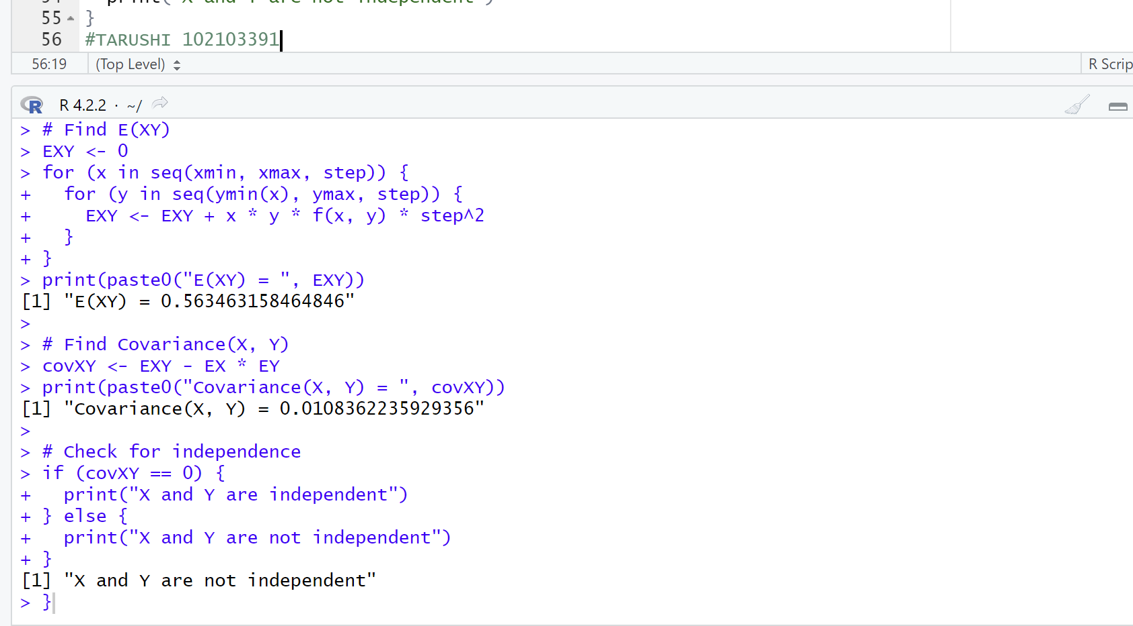

CODE –

# Define the joint probability density function

f <- function(x, y) {

if (x >= 0 & x < y & y <= 1) {

return(18 * x^2 * y^2)

} else {

return(0)

}

}

# Define the range of integration

xmin <- 0

xmax <- 1

ymin <- function(x) x

ymax <- 1

# Define the step size for the Riemann sum approximation

step <- 0.001

# Find E(X)

EX <- 0

for (x in seq(xmin, xmax, step)) {

for (y in seq(ymin(x), ymax, step)) {

EX <- EX + x * f(x, y) * step^2

}

}

print(paste0("E(X) = ", EX))

# Find E(Y)

EY <- 0

for (y in seq(ymin(0), ymax, step)) {

for (x in seq(0, y, step)) {

EY <- EY + y * f(x, y) * step^2

}

}

print(paste0("E(Y) = ", EY))

# Find E(XY)

EXY <- 0

for (x in seq(xmin, xmax, step)) {

for (y in seq(ymin(x), ymax, step)) {

EXY <- EXY + x * y * f(x, y) * step^2

}

}

print(paste0("E(XY) = ", EXY))

# Find Covariance(X, Y)

covXY <- EXY - EX * EY

print(paste0("Covariance(X, Y) = ", covXY))

# Check for independence

if (covXY == 0) {

print("X and Y are independent")

} else {

print("X and Y are not independent")

}

#TARUSHI 102103391

2.

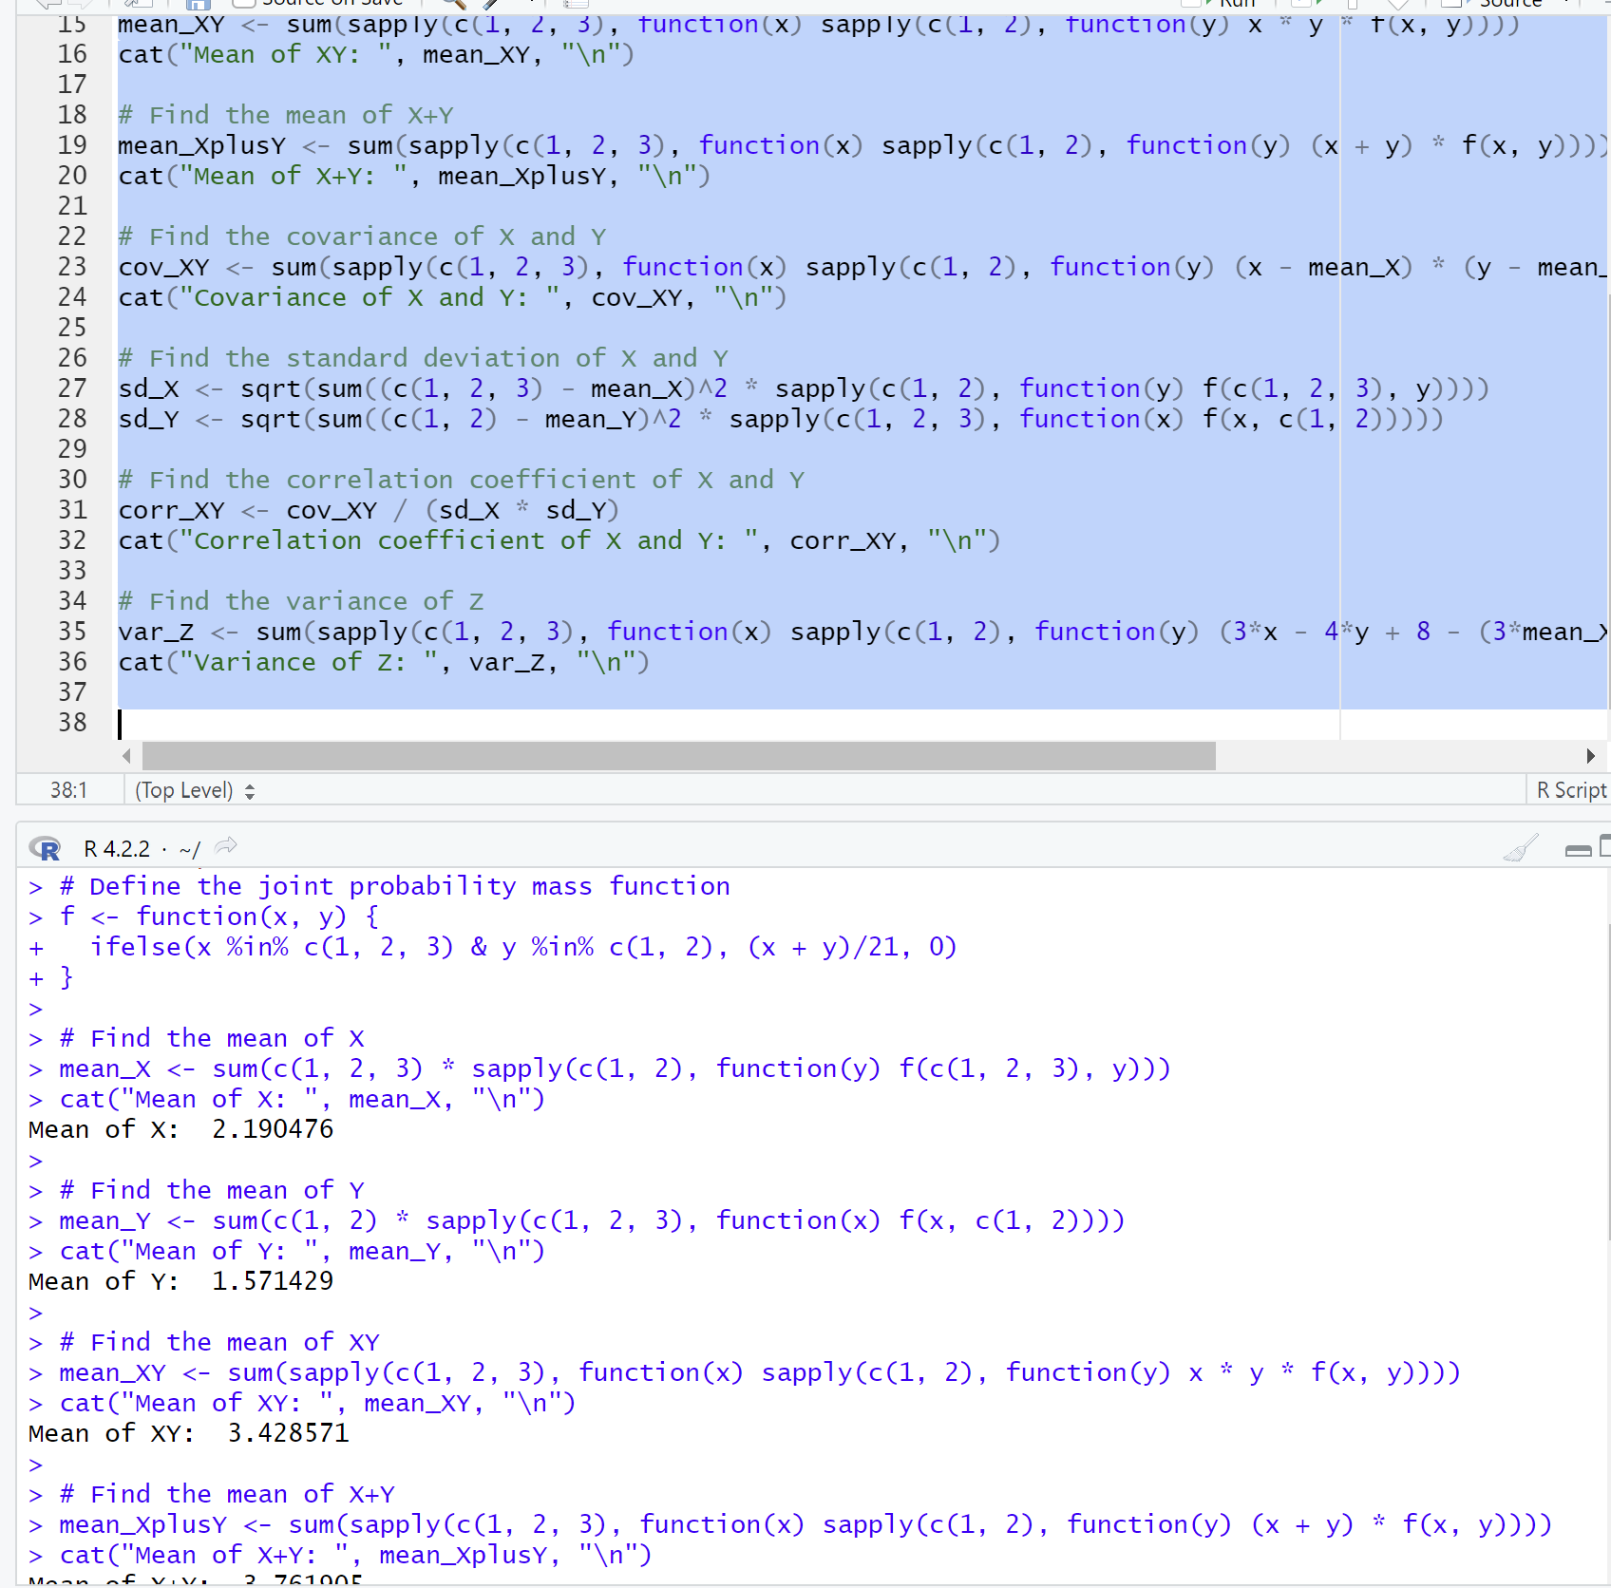

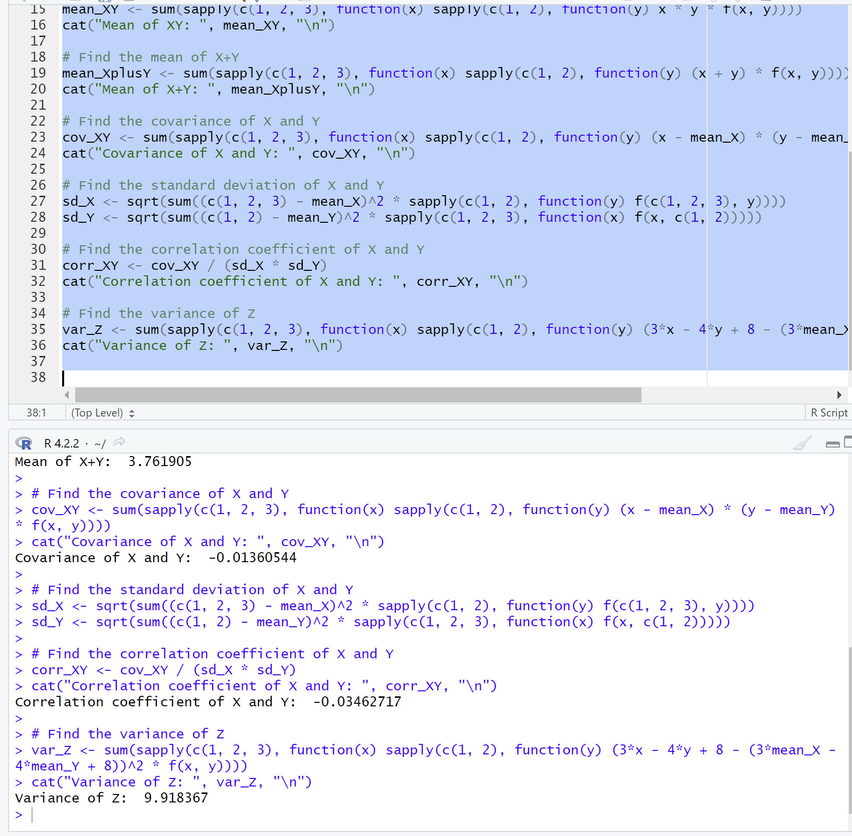

CODE –

# Define the joint probability mass function

f <- function(x, y) {

ifelse(x %in% c(1, 2, 3) & y %in% c(1, 2), (x + y)/21, 0)

}

# Find the mean of X

mean_X <- sum(c(1, 2, 3) * sapply(c(1, 2), function(y) f(c(1, 2, 3), y)))

cat("Mean of X: ", mean_X, "\n")

# Find the mean of Y

mean_Y <- sum(c(1, 2) * sapply(c(1, 2, 3), function(x) f(x, c(1, 2))))

cat("Mean of Y: ", mean_Y, "\n")

# Find the mean of XY

mean_XY <- sum(sapply(c(1, 2, 3), function(x) sapply(c(1, 2), function(y) x * y * f(x, y))))

cat("Mean of XY: ", mean_XY, "\n")

# Find the mean of X+Y

mean_XplusY <- sum(sapply(c(1, 2, 3), function(x) sapply(c(1, 2), function(y) (x + y) * f(x, y))))

cat("Mean of X+Y: ", mean_XplusY, "\n")

# Find the covariance of X and Y

cov_XY <- sum(sapply(c(1, 2, 3), function(x) sapply(c(1, 2), function(y) (x - mean_X) * (y - mean_Y) * f(x, y))))

cat("Covariance of X and Y: ", cov_XY, "\n")

# Find the standard deviation of X and Y

sd_X <- sqrt(sum((c(1, 2, 3) - mean_X)^2 * sapply(c(1, 2), function(y) f(c(1, 2, 3), y))))

sd_Y <- sqrt(sum((c(1, 2) - mean_Y)^2 * sapply(c(1, 2, 3), function(x) f(x, c(1, 2)))))

# Find the correlation coefficient of X and Y

corr_XY <- cov_XY / (sd_X * sd_Y)

cat("Correlation coefficient of X and Y: ", corr_XY, "\n")

# Find the variance of Z

var_Z <- sum(sapply(c(1, 2, 3), function(x) sapply(c(1, 2), function(y) (3*x - 4*y + 8 - (3*mean_X - 4*mean_Y + 8))^2 * f(x, y))))

cat("Variance of Z: ", var_Z, "\n")